# Name: Abdurrahman Qureshi

# Roll no: 210451

## Practical no 13: -

## Aim: PL/SQL Programs Based on Implicit and Explicit Cursors

1. Write a PL/SQL program for displaying details of employees working in Computer department using cursor.

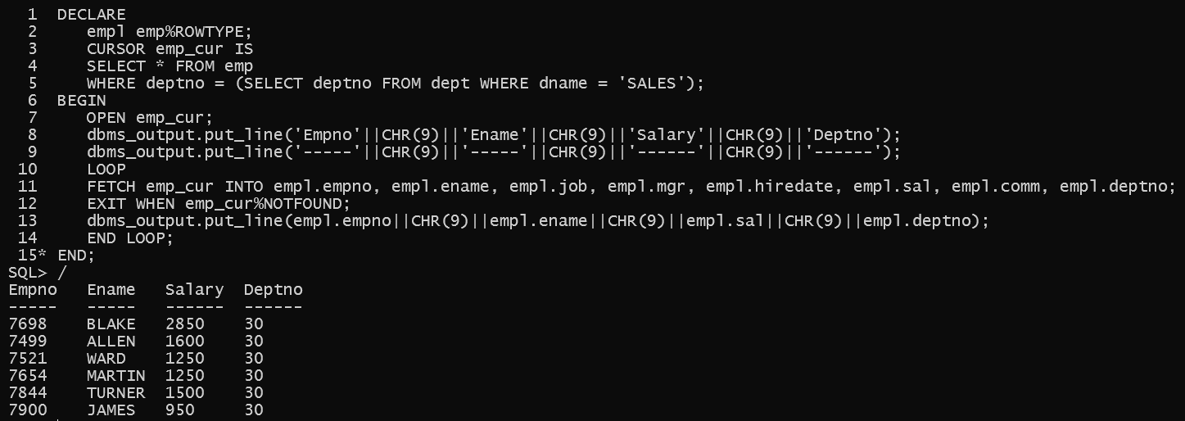

1. Write PL/SQL program using cursor to print the name, job of employees having Designation as Manager or Analyst.

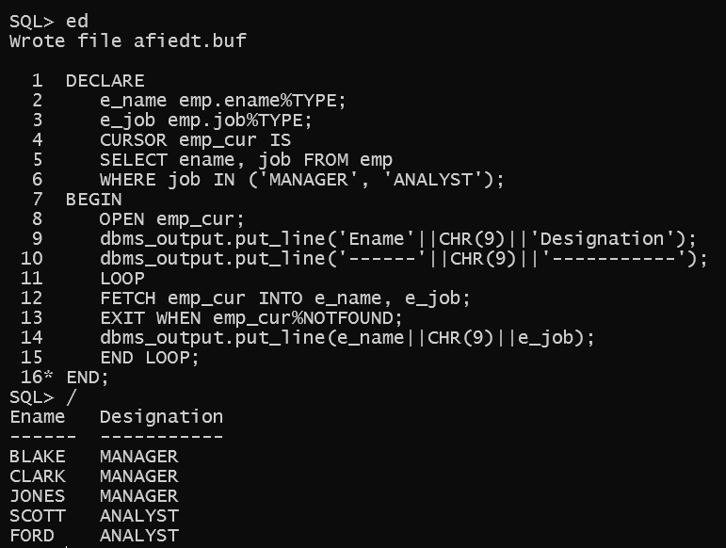

1. Write a PL/SQL code to print 4th,6th and 8th records from emp table.

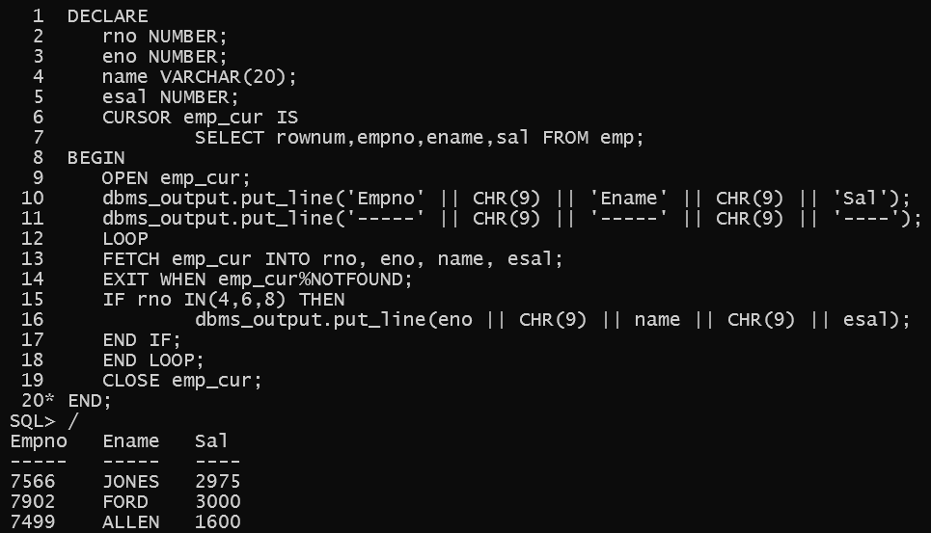

* **Exercise**

1. Write a PL/SQL program to print the details of first five highest salary earner employees.

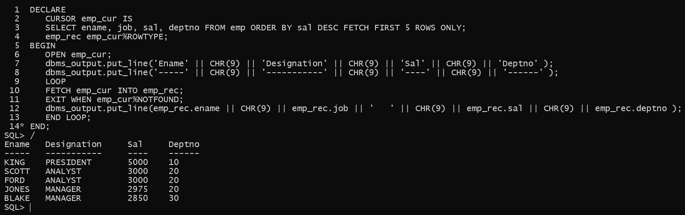

1. Write a PL/SQL program to update salary by 15% of employees working in IT Department and store this information in emp table as empno, sysdate and changed salary.

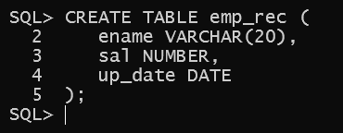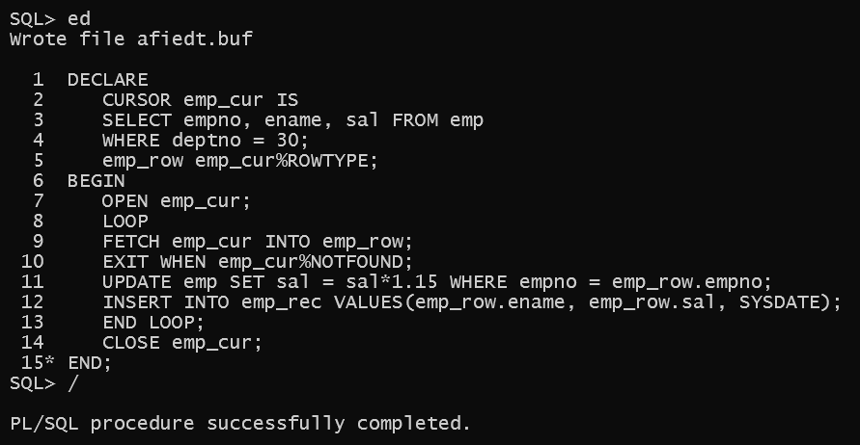

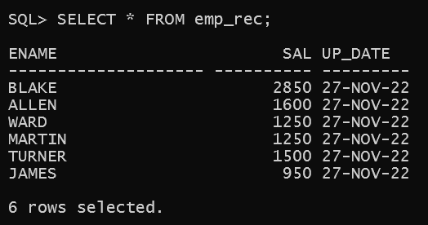

1. a)

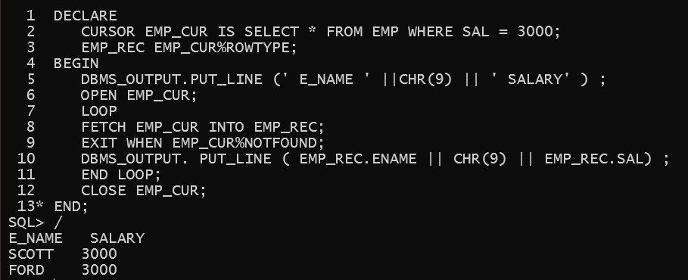

3.b)

